Final Project Report

Personal Fitness Tracker



Project Supervisor

Muhammad Zafar Nazir

Submitted By

F25PROJECTB6F33
Ali Hasnain BC230411456

Software Projects & Research Section,
Department of Computer Sciences,
Virtual University of Pakistan

CERTIFICATE

This is to certify that Ali Hasnain (BC230411456) has worked on and completed their Software Project at Software & Research Projects Section, Department of Computer Sciences, Virtual University of Pakistan in partial fulfillment of the requirement for the degree of BS in Computer Sciences under my guidance and supervision.

In our opinion, it is satisfactory and up to the mark and therefore fulfills the requirements of BS in Computer Sciences.

Supervisor / Internal Examiner

Muhammad Zafar Nazir
Supervisor,
Software Projects & Research Section,
Department of Computer Sciences
Virtual University of Pakistan

___________________
(Signature)

External Examiner/Subject Specialist
<<External Supervisor Name>>

___________________
(Signature)

Accepted By:

_____________
(For office use)

EXORDIUM

In the name of Allah, the Compassionate, the Merciful.

Praise be to Allah, Lord of Creation,
The Compassionate, the Merciful,
King of Judgment-day!

You alone we worship, and to You alone we pray for help,
Guide us to the straight path

The path of those who You have favored,

Not of those who have incurred Your wrath,
Nor of those who have gone astray.

DEDICATION

I dedicated this project to my beloved Parents, Freinds and Honourable Teachers.

ACKNOWLEDGEMENT

I would like to express my sincere gratitude to my esteemed supervisor, Muhammad Zafar Nazir, whose invaluable guidance and insightful suggestions played a pivotal role in the completion of this project. His unwavering support and expertise were instrumental at every stage, enabling me to navigate challenges successfully. I extend my thanks to all the teachers who provided me with essential tools and knowledge, crucial for the successful execution of this project.
I am also deeply appreciative of the unwavering support from my friends and parents. Their encouragement and assistance were invaluable, contributing significantly to the successful completion of my project.

PREFACE

First chapter is “Gathering and Analyzing Info” which includes SRS Document. Its sub sections include Introduction and Scope of the project and Purpose, a comprehensive detail about the Use Cases, and Work Plan (Gantt chart).
Second chapter is “Designing the Project” which includes Design phase documents. Sections of this chapter are Introduction, Data Flow Diagram, Entity relationship Diagram, Database Model and Graphical User Interfaces.
Third chapter is “Development Plan”.

TABLE OF CONTENTS

CHAPTER NO. 1
Software requirements specification (SRS Document)

1.1 scope
1.2 Functional & non-fucntional)
1.3 Use Case Diagram
1.4 Work Plan (Use MS Project to create Schedule/Work Plan)

CHAPTER NO. 2
designing the project (Design Document)
2.1 Introduction of Design Document
2.2 Data Flow Diagram (DFD)
2.3 Entity Relationship Diagram (ERD)
2.4 Database Design
2.5 Interface Design

CHAPTER 1
SOFTWARE REQUIREMENTS SPECIFICATION (SRS DOCUMENT)

1.1 Scope of Project:

The Personal Fitness Tracker is a web-based application designed to help individuals manage their fitness activities and monitor health progress. The system will cater to four types of users: Admin, Trainer, Registered User, and Unregistered User, each with specific roles and privileges.
User Management
• Registration and login for registered users and trainers.
• Admin control over adding, updating, and deleting user and trainer accounts.
Content Management
• Admin can publish and manage general fitness tips, workout routines, and nutritional advice visible to all users.
Activity Tracking
• Registered users can log workouts, meals, and water intake.
• Progress tracking through statistics, charts, and reports.
Feedback & Interaction
• Users can share feedback on routines and diet plans.
• Trainers can respond with suggestions or encouragement.
• Admin can monitor feedback and user activity logs.
Public Access
• Unregistered users can browse general fitness content but must register to access personalized features.
User Interface:
• Simple and intuitive UI for easy navigation.
• Responsive design to ensure accessibility on various devices (desktop, tablet, mobile).
1.2 Functional and non Functional Requirements:

Functional Requirements

Non Functional Requirements

A Non-Functional Requirement (NFR) defines the quality attribute of a software system. They judge the software system based on Performance, Usability, Maintainability, Portability and other non-functional standards that are critical to the success of the software system. These are also called quality attributes.

Performance: Performance requirements concern the speed of operation of a system. The non-functional requirements should identify those software functions that have constraint on their performance.

Maintainability: Maintainability requirements may cover diverse levels of documentation, such as system documentation, as well as test documentation, e.g. which test cases and test plans will accompany the system.

Usability: It is an easy way for a user to learn to operate. It is well-formed GUI.

Portability: Portability specifies the ease with which the software can be installed on all necessary platforms, and the platforms on which it is expected to run.

Reliability: Reliability is the ability of a system to perform its required functions under specific period of time.

Time: The project speed is very high. Every task takes low time for completion.

User-Friendly Interfaces: All interfaces should have intuitive design and easy navigation, ensuring accessibility for all users.

Validation Checks: Implement validation checks across all entry, update, delete, and search interfaces to ensure data integrity and accuracy.

1.3 Use Case Diagram

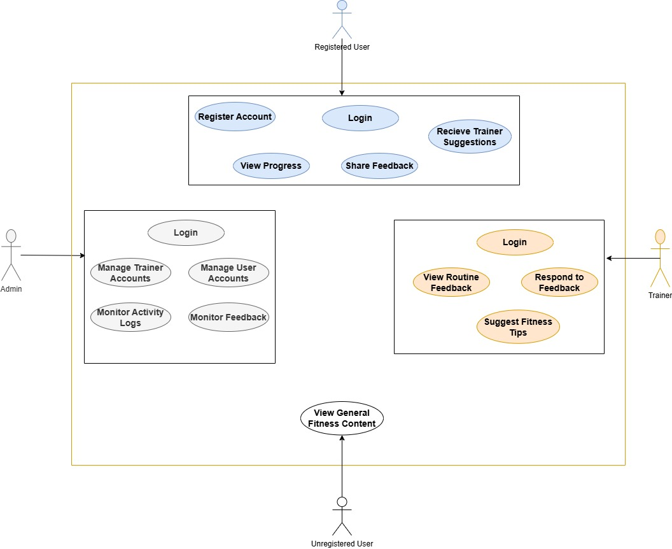

1.4 Work Plan

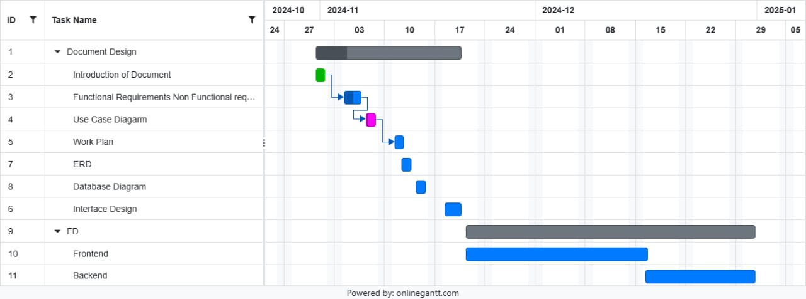

CHAPTER 2
Designing the Project
(Design Document)

  - Introduction of Design Document
The Design Document is like a detailed plan for building a software system. It's a guide that shows software developers how to turn ideas and requirements into an actual working program. In simple words, it's like a map that explains what the software will do, how different parts will work together, and why certain choices are made during the development process. This document helps everyone involved understand the project better and ensures that the software is built the way it's supposed to be. It's not just a guide for now, but also a reference for the future if any changes or improvements need to be made to the software.
Design Document Includes
- Entity Relationship Diagram (ERD)
- Data Flow Diagram (DFD)
- Database Design
- Interface Design
Entity Relationship Diagram (ERD)
An ERD, or Entity-Relationship Diagram, is a visual representation illustrating how different groups of entities are connected within a database. Essentially, it acts as a roadmap detailing the logical organization of a database. ER diagrams include Entities (depicted as rectangles), Attributes (shown as ellipses), and Relationships (represented by diamond shapes). In simpler terms, an ER diagram is a tool that helps explain how various pieces of information are related in a database, using shapes to represent different components like entities, attributes, and relationships.
Database Design
Database design is like creating a plan for how information is organized. It involves deciding what things (entities) to keep track of, what details (attributes) each thing should have, and how these things are related. A good design makes it easy to manage information, keeps everything consistent, and uses storage space wisely. So, it's like making a roadmap for storing and organizing data in a smart and efficient way.
Interface Design
The user interface is how a software application looks and feels, serving as the means through which users engage with and operate the software. It allows users to interact with both the software and hardware components, providing a bridge for control and operation. Essentially, the user interface is a vital part of the software, carefully crafted to help users navigate and comprehend the application. It forms the foundation for human-computer interaction, offering a basic platform for users to interact seamlessly with the software.

  - Data Flow Diagram (DFD)

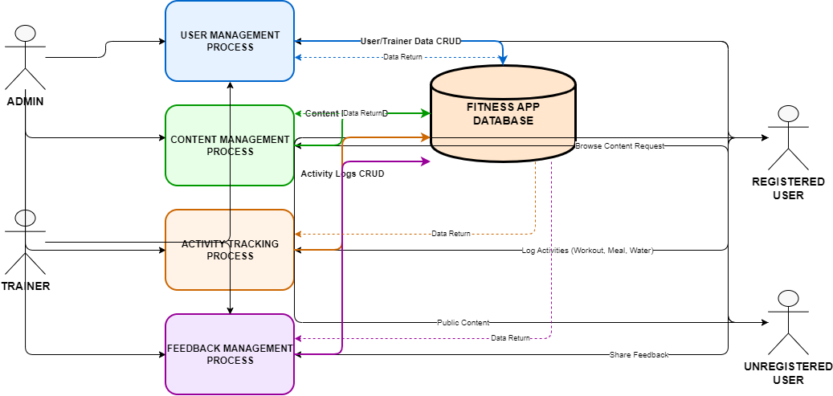

  - Entity Relationship Diagram (ERD)
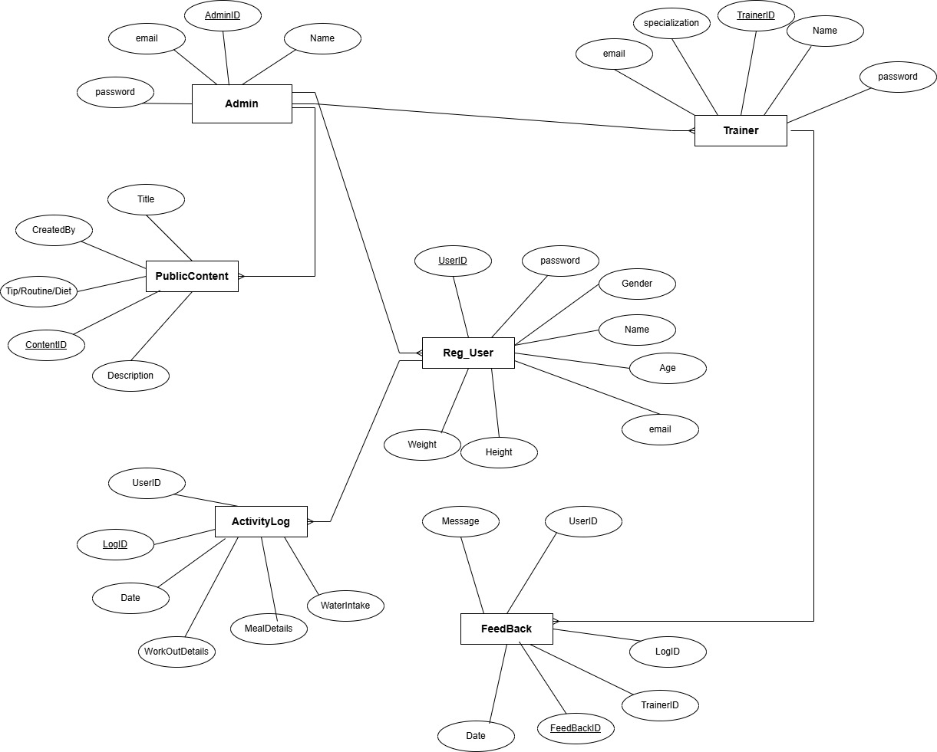

  - Database Design

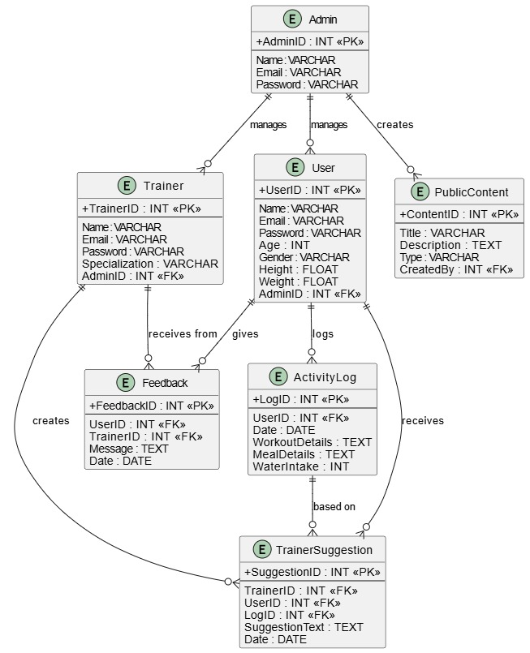

  - Interface Design (Optional)

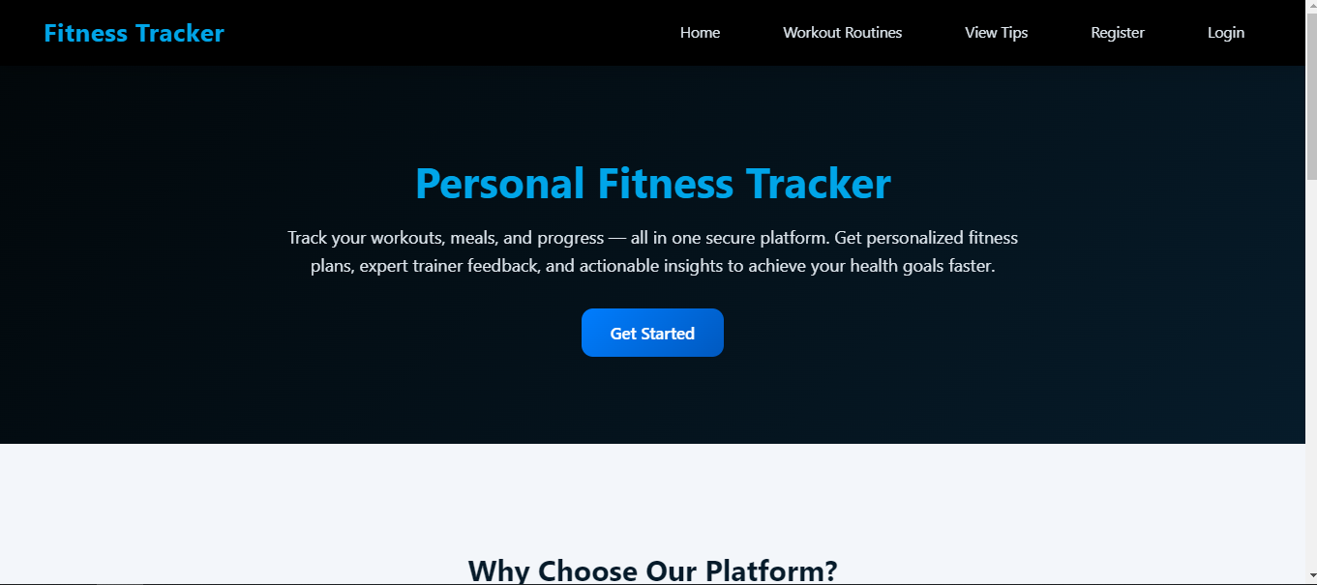

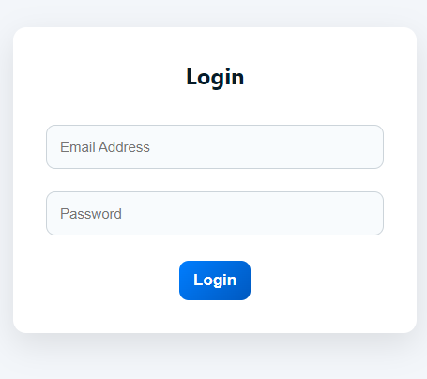

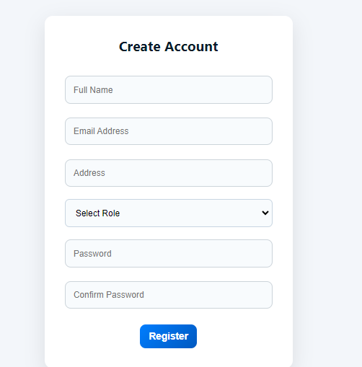
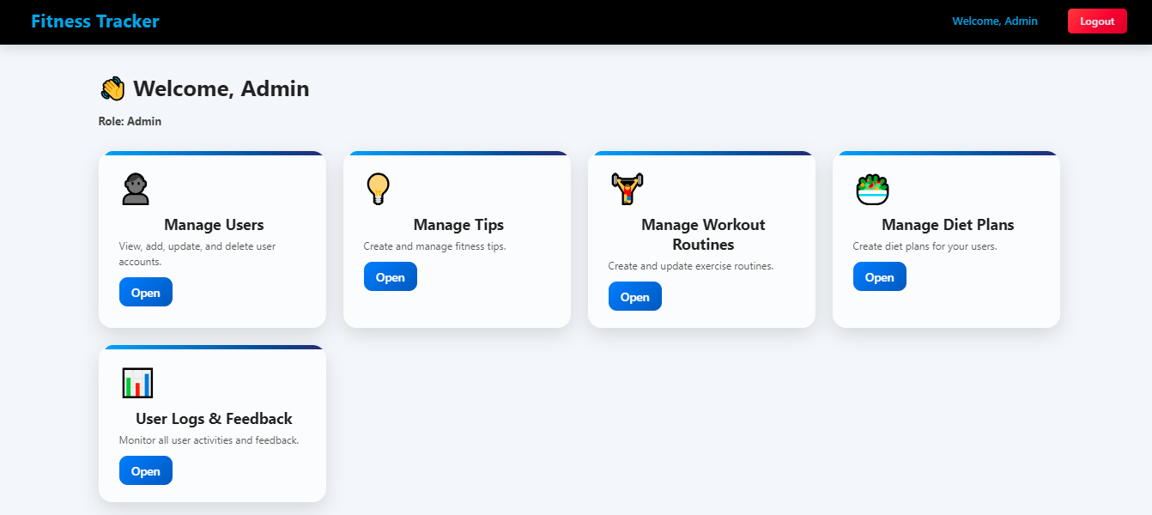

REFERENCES

http://www.tutorialspoint.com/
http://www.homeandlearn.co.uk/
http://www.w3schools.com/

